Angel Gowns by Analane
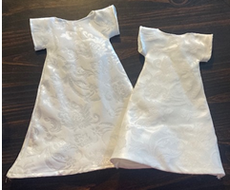
Angel Gown Dress Sewing Instructions
Items Needed:
- Sewing Machine
- Straight Pins
- Scissors
- Steam Iron or an Iron & Water
- White Thread
- White Fabric
- Two 8-inch Pieces of White Ribbon
Step 1: Cutting Pattern Pieces (if the pieces are already cut, you may skip this step)
  - Gown Cutting Front Piece (using pattern pieces 1A, 2A, or 3A)
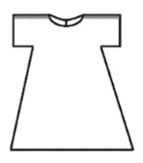
Fold the fabric with the right sides together. Place the edge of the pattern piece that says “fold line” along the fold. Cut around the other edges. Each gown needs one front piece.
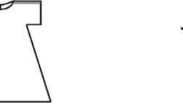
Edge of folded fabric
Fold
Cutting Line
Fabric
Finished Cut Piece.

  - Gown Cutting Back Pieces (using pattern pieces 1B, 2B, or 3B)
Fold the fabric, with right sides together. Place the edge of the pattern piece near fold. Cut around all edges. Each gown needs two back pieces.
Edge of folded fabric
Fold
Fabric
Cutting Line

Finished Cut Pieces.

Step #2: Ironing:
Make sure all pieces are ironed and there are no wrinkles.

Step #3 Sewing Shoulder Seams:
With the right sides of the fabric together, pin the back pieces to the front piece matching the shoulder. Using a ¼ inch seam allowance, sew the top shoulder seam on both the right shoulder and the left shoulder.
Seam Line
Seam Lines

Step #4 Sewing Outer Sleeve Hem:
Lay the fabric piece open with the right side of the fabric down. Fold the outer edge of the sleeve fabric in ¼ inch. Iron the fold. Using just under a ¼ inch seam allowance sew in the sleeve hem using a straight stitch. Do this to both sleeves.
Folded Edge Line
Seam Line

Back Opening Line

Folded Edge Line
Seam Line

Step #5 Sewing Side Seams:
With the right sides of fabric facing each other, so the wrong side of the fabric is out, using a ¼ inch straight seam, sew the side seams of the dress starting with the bottom of the sleave, going the end of the fabric.
Clip here after sewn.
Clip here after sewn.

Seam Line
Seam Line

After sewing the side seams, clip the fabric in the armpit area of the dress. Be careful not to cut the stitching.

Step #6 Sewing Neckline and Back Flaps
Using a zig zag stitch, stitch along the back openings and the entire neckline of the dress. After the zig zag stitch is complete, fold over the edge of the fabric about ¼ inch, and straight stitch the fabric in place.
Seam Line

Back Opening Line
Seam Line

Step #7 Sewing Bottom Hem
Zig Zag the bottom of the fabric. After the zig zag stitch is complete, fold the edge of the fabric over about ¼ inch and then fold again ¼ inch to hide the raw edge and straight stitch the fabric in place. Note: Because of the triangle shape of the fabric, it may be necessary to ease in the fabric to make the hem.
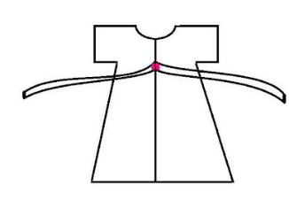
Step #8 Sewing Back Ribbon Tie
On the back side of the dress, about 1 ½ inches down from the neckline, sew one
piece of ribbon on the edge each panel. This is to allow the dress to be tied closed.

Step # 9 Iron
After the dress is completely sewn, Iron down the side seams to help the dress keep the shape.

